UNIT-I
INTRODUCTON TO COMPUTER SYSTEM
1.What is Computer & Computer System
A computer is an electronic device that can be programmed to accept data (input), process it (processing) and generate result (output) IPO . A computer along with additional hardware and software together is called a computer system..
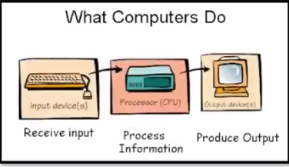

2. Draw the block diagram of a computer system. Briefly write about the functionality of each component
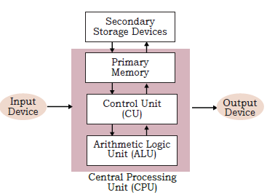

A computer system primarily comprises of a. Central Processing Unit (CPU),
b. input/output (I/O) devices c. Memory, & d. storage devices.

Central Processing Unit (CPU) :It is the electronic circuitry of a computer that carries out the actual processing and is usually referred to as the brain of the computer, It is also commonly called 'processor'. CPU has two main components — Arithmetic Logic Unit (ALU) and Control Unit (CU).
ALU performs all the arithmetic and logic operations that need to be done as per the instruction in a program.
CU controls sequential instruction execution, interprets instructions and guides data flow through the computer’s memory,
Input Devices -The devices through which control signals are sent to a computer are termed as input devices
Ex:Keyboard,Scanner,Mouse,Touch Screen,Google voice seacrch,microphone etc…..
Output Devices :The device that receives data from a computer system for display, physical production, etc., is called output device
Ex: Monitor, Speaker,Printer,Projector,Headphone
Computer Memory :A computer system needs memory to store the data and
instructions for processing. computers have two types of memories namely —Primary Memory(Main Memory) –Volatile and Secondary Memory(Secondary storage-(Non-Volatile)
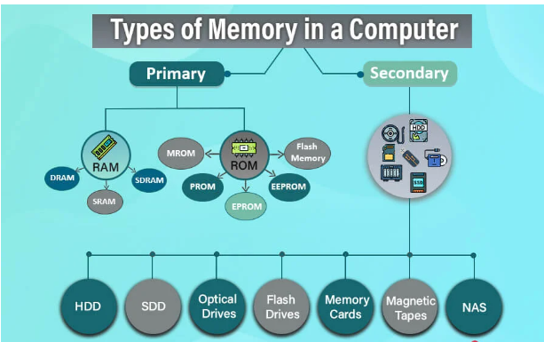.
PRIMARY MEMORY
RAM:Random Access Memory ROM:Read Only Memory
DRAM:Dynamic RAM MROM:Masked ROM
SRAM:Static RAM PROM: Programmable ROM
SDRAM: Synchronous Dynamic RAM EPROM: Erasable PROM
EEPROM: Electrically EPROM
SECONDARY MEMORY
HDD: hard disk drives Optical Drives:- CDs, DVDs, Blu-ray
SDD: solid-state drives Flash Drives: USB drives, SD cards,
NAS:Network Attached Storage Magnetic tapes.
PRIMARY MEMORY: The primary memory is an essential component of a
computer system. Program and data are loaded into the primary memory before processing. It is of two types viz. i) Random access memory (RAM), and
ii) Read only memory (ROM).
RAM | ROM
RAM is volatile i.e. as long as the power is supplied to the computer, it retains the data in it. | ROM is non-volatile, means its contents are not lost even when the power is turned off.
It is used to store data temporarily | It is used to store data Permanently
Memory is very Fast | It is very slow
Running applications and processes | Booting the computer
Allow Reading & Writing | Allows Read only
RAM is Expensive(Costly) | ROM is Cheap

SECONDARY MEMORY :A computer system needs auxiliary or secondary memory to permanently store the data or instructions for future use.

The secondary memory is non-volatile and has larger storage capacity than primary memory. It is slower and cheaper than the main memory.

There are secondary storage devices like Solid-State Drive (SSD) which support very fast data transfer speed as compared to earlier HDDs. Also, data transfer between computers have become easier and simpler due to the availability of small sized and portable flash/pen drives.

CACHE MEMORY: To speed up the operations of the CPU, a very high speed memory is placed between the CPU and the primary memory known as cache. It stores the copies of the data from frequently accessed primary memory locations

Units of Memory :A computer system uses binary numbers to store and process data.The binary digits 0 and 1, which are the basic units of memory, are called bits.
4 bits = 1 Nibble Ex:1001 &
8 bits= 1 Byte Ex:10101011
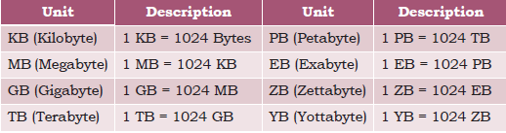
1.2 Evolution of Computer : From the simple calculator to a modern day powerful data processor, computing devices have evolved in a relatively short span of time.
Electronic Numerical Integrator And Computer (ENIAC) is the first binary programmable computer based on Von Neumann architecture. 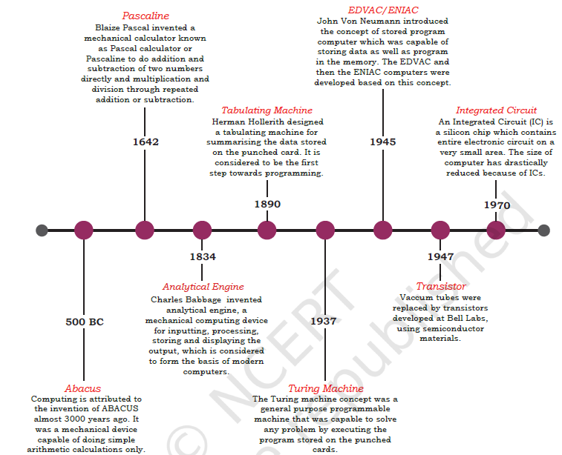

1.3.3 Data Capturing, Storage, and Retrieval:
(A) Data Capturing: It involves the process of gathering data from different sources in digital form. Data may be captured using, keyboard bar code readers remore sensors on earth orbiting satellites etc. comments/ports over multiple social media are also captured as data.
(B) Data Storage :It is the process of storing the captured data for processing later. In large organisations, computers with larger and faster storage called data servers are deployed to store vast amount of data.
(C) Data Retrieval :It involves fetching data from the storage devices, for its processing as per the user requirement.
Ex:CCTV,IBOMMA,LIBRARY
1.3.4 Data Deletion and Recovery:
Data Deletion: One of the biggest threats associated with digital data is its deletion. The storage devices can malfunction or crash down resulting in the deletion of the stored data. Users can accidentally erase data from storage devices, or a hacker/malware can delete the digital data intentionally. Data deletion refers to the process of removing data from storage devices (e.g., hard drives, SSDs, USBs). Malware (short for malicious software) is any software intentionally designed to harm, disrupt, or exploit computers, networks, or data.
Data recovery: Data recovery is a process of retrieving deleted, corrupted and lost data from secondary storage devices.
Data Recovery Methods:-
1. Using Recycle Bin / Trash :Most files can be recovered from here unless permanently deleted.
2. File Recovery Software: Recuva, EaseUS, Stellar Data Recovery, Disk Drill.
3. Backup Recovery:Restore from system backups, cloud backups (Google Drive, OneDrive), or Time Machine (Mac).

Hardware: Hardware refers to the physical components of the computer system which can be seen and touched. For example, RAM, keyboard, printer, monitor, CPU etc.

A document or image stored on the hard disk or pen drive is referred to as a softcopy. Once printed, the document or an image is called a hardcopy.

Software:Software is a set of instructions and data that makes hardware functional to complete the desired task. Each software is written for some computational purpose. Some examples of software include operating systems like Ubuntu or Windows 7/10, word processing tools like LibreOffice Writer or Microsoft Word, video player like VLC Player, photo editors like Paint and LibreOffice Draw

Types of Softwares :Software can be broadly classified into three categories viz. i) System software ii) Programming tools and iii) Application software
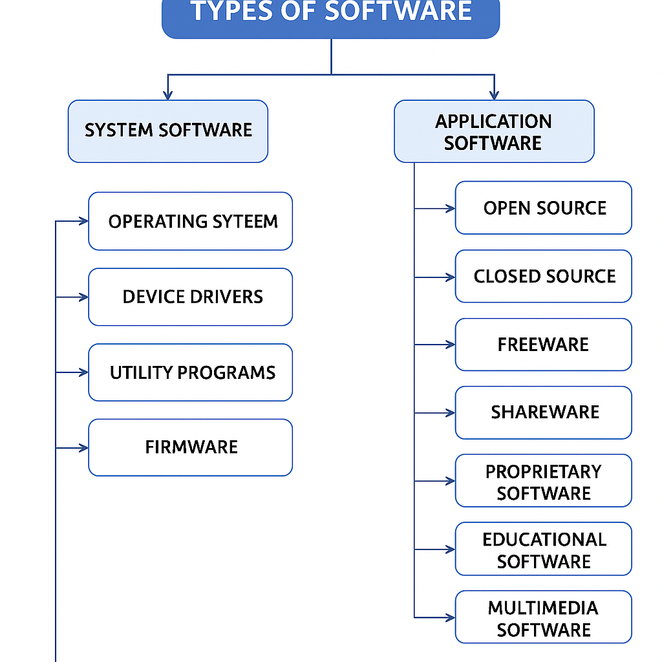
System software: The software that provides the basic functionality to operate a computer by interacting directly with its constituent hardware is termed as system software. Examples of system software include operating systems, system utilities, device drivers, etc.
(A) Operating System : is a system software that operates the computer. An operating system is the most basic system software, without which other software cannot work. The operating system manages other application programs and provides access and security to the users of the system.
Some of the popular operating systems are Windows, Linux, Macintosh, Ubuntu, Fedora, Android, iOS, etc.

(B) System Utilities :Software used for maintenance and configuration of the computer system is called system utility. for example disk defragmentation tool, formatting utility, system restore utility, etc. Another set of utilities are those which are not shipped with the operating system but are required to improve the performance of the system, for example, anti-virus software, disk cleaner tool, disk compression software, etc.

(C) Device Drivers :the purpose of a device driver is to ensure proper functioning of a particular device. The device driver acts as an interface between the device and the operating system. It provides required services by hiding the details of operations performed at the hardware level of the device.

Application software is a computer program designed to help users do specific tasks or activities such as writing documents, watching videos, browsing the internet, or managing data.
There are again two broad categories of application software: general purpose software and customised application software.

(A) General Purpose Software :The application software developed for generic applications, to cater to a bigger audience in general are called general purpose software Ex:MS-Office

For example, spreadsheet tool LibreOffice Calc can be used by any computer user to do calculation or to create an account sheet. Adobe Photoshop, GIMP, Mozilla web browser, iTunes, etc. fall in the category of general purpose software.

(B) Customised Software
These are custom or tailor-made application software, that are developed to meet the requirements of a specific organisation or an individual.

Some examples of user-defined software include websites, school management software, accounting software, etc.

Proprietary or Free and Open Source Software (FOSS)
Developers of some software allow public to freely use their software along with source code with an aim to improve further with each other’s help. Such software is known as Free and Open Source Software (FOSS).

Ex: Python, Libreoffice, Openoffice, Mozilla Firefox,VLC Media Player.

Proprietary software is software that is owned by a company or individual, and you cannot see, modify, or share its source code. You usually need to buy a license to use it.

Ex: MS Office, Adobe Photoshop,Tally

NCERT TB SOLUTIONS
Exercise
1. Name the software required to make a computer functional. Write down its two primary functions.
Ans: Ans. The software required to make a computer functional is Operating System (OS). It’s two primary services are :
Memory management : It manages Primary or main memory of a computer system.
Device Management : It interacts with the device driver and the related software for a particular device.

2. What is the need of RAM? How does it differ from ROM?
RAM | ROM
RAM is volatile i.e. as long as the power is supplied to the computer, it retains the data in it. | ROM is non-volatile, means its contents are not lost even when the power is turned off.
It is used to store data temporarily | It is used to store data Permanently
Memory is very Fast | It is very slow
Running applications and processes | Booting the computer
Allow Reading & Writing | Allows Read only
RAM is Expensive(Costly) | ROM is Cheap
3. What is the need for secondary memory?
The secondary memory (also called storage device) is required to store data, instructions and results permanently for future use.

4. Draw the block diagram of a computer system. Briefly write about the functionality of each component.
Ans. A computer system primarily comprises a Central Processing Unit (CPU), memory, input/output devices and storage devices.
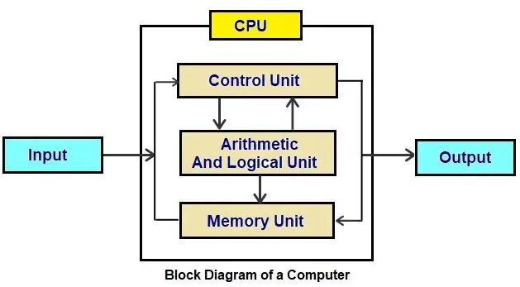 CPU : The CPU has two main components — Arithmetic Logic Unit (ALU) and Control Unit (CU). ALU performs all the arithmetic and logical operations. The control unit controls the sequence in which computer programs and instructions are executed.
2. Input Device : The devices through which data/signals are sent to a computer are termed as input devices. for example : keyboard, mouse, scanner etc.
3. Output Devices : The device that receives data from a computer system for display is called output device. It converts digital information into human understandable form. For example, monitor, projector, headphone, speaker, printer, etc.
4. Storage Devices : A computer system needs memory to store the data and instructions for processing. Those devices which stores data for processing are called storage devices like Hard Disk, SSD etc
5. Differentiate between proprietary software and freeware software. Name two software of each type.
Ans.
Proprietary Software | Freeware Software
Source code is not available | Source code is available
Not free to use | Free to use
example : Microsoft Windows,  Microsoft Office | example : Python, LibreOffice,  Open office

6. Mention any browsers used for browsing the internet.
The most popular web browsers are Google Chrome, Microsoft Edge (formerly Internet Explorer), Mozilla Firefox, and Apple's Safari.

7. Name the input/output device used to do the following:
a) To output audio | Speaker
b) To enter textual data | Keyboard
c) To make hard copy of a text file | Printer
d) To display the data/information | Monitor
e) To enter audio-based command | Microphone
f) To build 3D models | 3D Printers
g) To assist a visually impaired individual in entering data | Braille keyboards

8. Identify the category (system, application, programming tool) of the following software:
a) Compiler | System Software
b) Assembler | System Software
c) Ubuntu | System Software
d) Text editor | Programming Tool
9. Convert the following into bytes:
a) 2 MB | 2097152 bytes
b) 3.7 GB | 3972844748.8 bytes
c) 1.2 TB | 1319413953331.2 bytes

10. What is the security threats involved when we throw away electronic gadgets that are non-functional?
security threat can increase if the electronic gadgets and the magnetic strip inside the devices are not disposed properly. Personal detail, bank detail, important documents can be fetched through broken hard disk or memory card which can be used by hackers.
11. Write down the type of memory needed to do the following:
a) To store data permanently | Secondary Storage like Hard Disk, Pen Drive, CD, DVD, SD Card, SSD etc
b) To execute the program | RAM–Random Access Memory
c) To store the instructions which can not be overwritten | ROM – Read Only Memory

